Frequently Asked Questions
REGIONAL MEASURE 3 / SENATE BILL 595
October 2017

- What is the goal of Senate Bill 595?
To support the Bay Area’s growing economy and quality of life, SB 595 aims to reduce congestion and improve transportation options throughout the Bay Area. This bill would give voters the chance to approve an increase in bridge tolls to finance urgently needed improvements, including (but not limited to) new BART cars, the extension of BART to Silicon Valley, new high-occupancy vehicle lanes on U.S. 101 in Marin and Sonoma counties, improvements to State Route 37, more frequent and expanded ferry service, improvements to the Interstate 80/680/State Route 12 interchange in Solano County, and the extension of Caltrain to downtown San Francisco.
- How much does the bill propose to raise tolls?

The bill would authorize the Bay Area Toll Authority (BATA), a regional agency that administers the Bay Area’s bridge tolls, to place a toll increase on the ballot in the amount of up to $3, to be determined by BATA, and allows the amount to be phased in over time. The bill would also allow BATA to adjust the tolls in the future according to the California Consumer Price Index to account for inflation.
- Which bridges would be affected by the toll rate increase?

Voter approval would affect the toll rates on the Bay Area’s seven state-owned toll bridges, which include the Antioch Bridge, the Benicia-Martinez Bridge, the Carquinez Bridge, the Dumbarton Bridge, the Richmond-San Rafael Bridge, the San Francisco-Oakland Bay Bridge and the San Mateo-Hayward Bridge. Tolls on the Golden Gate Bridge would not be affected as it is an independent district not overseen by BATA.
- When would voters consider the ballot measure authorized by SB 595?
Under the current version of the bill, the measure would appear on the ballot in November 2018. However, the MTC would like to amend the bill so that it would appear in June 2018 and not interfere with other local measures planned for November.

- When would the toll rate go into effect?
The bill currently specifies that it would take effect on January 1, 2019, but this could change if the date of the election is amended.
- How would the vote be tallied across counties?

Similar to Regional Measures 1 and 2, approved by Bay Area voters in 1988 and 2004 respectively, the measure would be approved if it receives a majority of support from all voters voting on the measure. Voters in all nine Bay Area counties would consider this measure, unlike Regional Measures 1 and 2 which were voted on by just seven of the nine counties (those measures did not appear on the ballot in the counties of Napa and Sonoma).

- What types of projects would be funded with the new toll revenues?
The expenditure plan for the measure is still under development and negotiation by members of the Bay Area caucus and key stakeholders. Similar to Regional Measures 1 and 2, it would likely include a combination of public transit, roadway and active transportation improvements that would improve mobility in the bridge corridors and along their approaches.

- How much money would be raised by each $1 toll increase?
Based on current traffic volumes, each dollar generates approximately $125 million in annual toll revenue. In terms of bonding capacity, this is equivalent to approximately $1.7 billion in capital projects over a 25-year bond term, assuming all funds are available for debt service and none are reserved for operational programs.

- How much money is generated from bridge tolls today and where do these funds go?
In FY 2015-16, toll revenue generated approximately $714 million. Of this amount $432 million was for the seismic retrofit program and $283 million was for Regional Measures 1 and 2. These funds pay for ongoing transit service along with debt service for the capital projects funded by the Toll Bridge Seismic Retrofit Program, Regional Measures 1 and 2 and bridge maintenance and rehabilitation.

- Would carpools receive a discount?

Carpools currently receive a 50% discount on tolls during carpool hours. This discount would stay in effect post-Regional Measure 3.

- Would trucks be subject to a higher axle based toll?

Trucks, regardless of the number of axles, would be subject to the same toll increase as passenger vehicles.

- When were the tolls last raised and by how much?
The table below provides a breakdown of the current $5 base toll rate for passenger vehicles.

Toll Increase Name | Amount
Regional Measure 1 (1989*) | $1 (standardized all tolls at $1)
Seismic Surcharge (1998) | $1
Regional Measure 2 (2004) | $1
Seismic Surcharge (2007) | $1
Antioch/Dumbarton Seismic Surcharge (2010) | $1
Total Auto Toll (2017) | $5
* Though Regional Measure 1 was approved in 1988, the toll increase did not go into effect until January 1, 1989.

- How much does each county pay in toll revenue?
See the pie chart below for a breakdown of existing toll revenues by county:

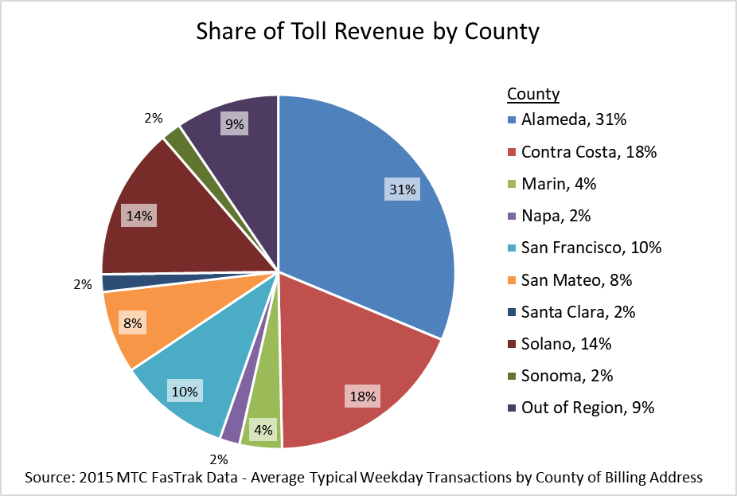
14. What is the current distribution of toll revenue by bridge?

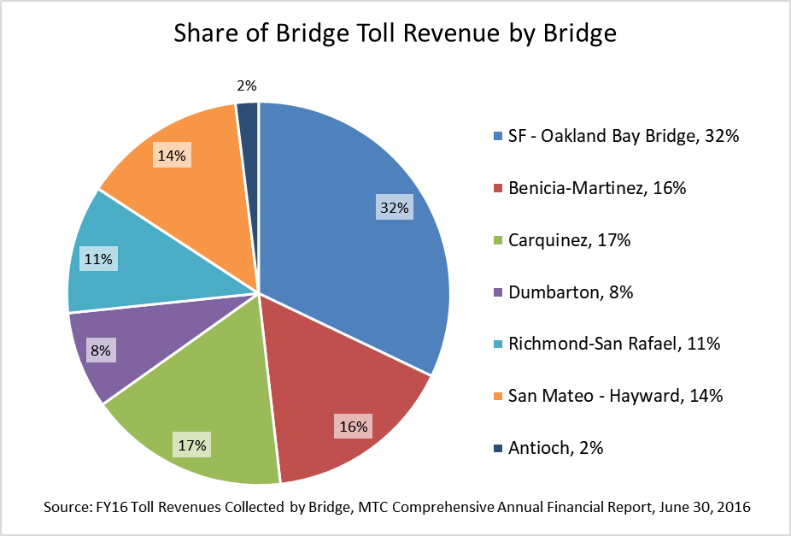

18. What is the approximate benefit, by county, of the proposed capital expenditures in SB 595?

- How do Bay Area bridge toll rates compare to other major bridges and toll roads?

See the chart below for toll rate comparisons:

Facility | Standard Auto Toll
BATA Bridges | $5.00
Golden Gate Bridge | $7.50/$6.50  (Plate/FasTrak)
MTA Verrazano Narrows Bridge* | $11.08/$16.00  (EZ-Pass/Cash)
Port Authority of New York/New Jersey  (Bridges and Tunnels) | $10.50/$12.50/$15.00  Off-Peak/Peak/Cash
* Reflects EZ-Pass discount rate

- What are Regional Measure 1 and Regional Measure 2?

Regional Measure 1 – approved by Bay Area voters in 1988 – established a uniform $1 base toll on the Bay Area’s seven state-owned toll bridges. The toll increase ranged from 25 cents to 60 cents at six Bay Area toll bridges – tolls at the Richmond-San Rafael Bridge, already $1, were unchanged by the measure. BATA used the increased revenues to issue bonds that financed major bridge and highway projects throughout the region.

Voters in 2004 approved Regional Measure 2, raising the toll on the region’s seven state-owned toll bridges by $1. The measure established a Regional Traffic Relief Plan to finance highway, transit, bicycle and pedestrian projects in the bridge corridors and their approaches, and to provide operating funds for key transit services. See the chart below for a list of major capital projects financed through these measures:

Projects | Regional Measure | Funds  (Dollars in Millions)
New Benicia Bridge | 1 | $1,200
Carquinez Bridge Replacement | 1 | $518
Transbay Transit Center* | 2 | $353
BART to Warm Springs* | 2 | $304
e-BART/Highway 4 Widening | 2 | $269
New I-880/92 Interchange | 1 | $235
San Mateo-Hayward Bridge Widening | 1 | $210
Oakland Airport Connector* | 2 | $146
I-80 HOV Lanes/Truck Scales* | 2 | $123
Richmond-San Rafael Trestle and Deck | 1 | $117
SMART Rail Extension | 2 | $82
AC Transit Rapid Bus | 2 | $78
Transit Center Upgrades and New Buses | 2 | $65
Regional Ferry Vessels | 2 | $46
Bayfront Expressway Widening | 1 | $36
BART Tube Seismic Retrofit | 2 | $34
Note: Not a comprehensive list of expenditure plans. Projects marked with an asterisk have received additional toll revenues in addition to Regional Measure 2.

- What were the vote results for Regional Measures 1 and 2?

See below for the vote results for Regional Measures 1 and 2 by county. Note that these measures were on the ballot in seven of the nine Bay Area counties. SB 595 would authorize BATA to place a toll increase on the ballot in all nine Bay Area counties.

 | Regional Measure 1  (1998) |  | Regional Measure 2  (2004)
 | Yes | No | Yes | No
Alameda17o | 71% | 29% | 56% | 44%
Contra Costa | 68% | 32% | 51% | 49%
Marin | 76% | 24% | 64% | 36%
San Francisco | 69% | 31% | 69% | 31%
San Mateo | 74% | 26% | 55% | 45%
Santa Clara | 71% | 29% | 60% | 40%
Solano | 58% | 42% | 41% | 59%
Total | 70% | 30% | 57% | 43%

